LAB Logbook

Lab 1
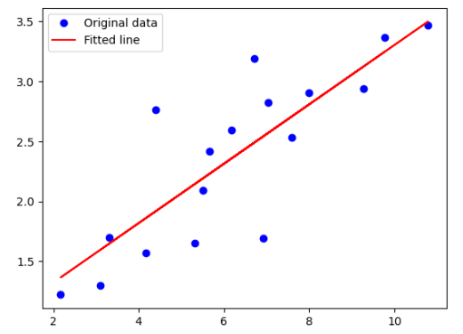

Lab 2
Accuracy is "0.98"
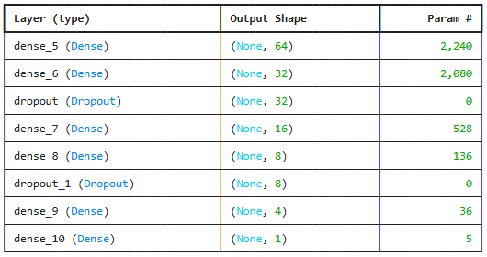
Lab 3
Accuracy is "0.88"

Model summary

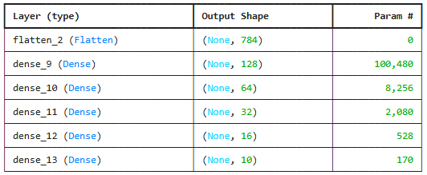

Lab 4

Lab 5

Lab 6

Lab 7

Lab 8

Lab 9

Lab 10

Lab 11

Lab 12

